DOCUMENTING THE USER EXPERIENCE
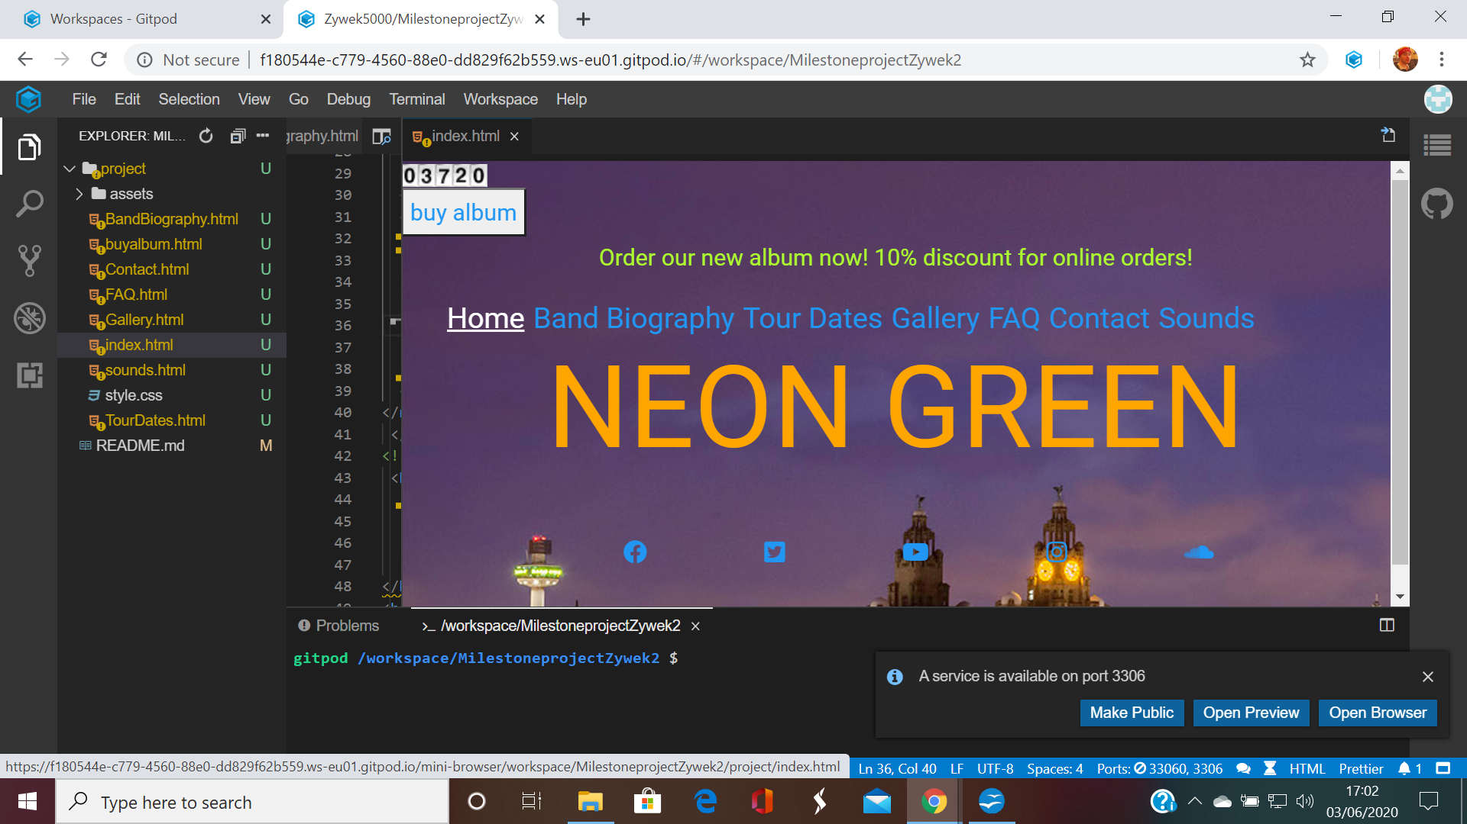
First page of the site, demonstrating the responsive Nav-bar, with easy to see, clear wording, which becomes highlighted when the user hovers the cursor over it. The 'Home' Page is currently highlighted. Below the Nav-Bar, is a footer containing social media links associated with the band. These have been presented in the same fashion as the top Nav-Bar. A flashing text at the top of the screen notifies fans of the new album, along with a discount if ordered online. This is designed to attract more sales. In addition, a 'buy album' button is situated to the left, containing a link to a card details page. The 'buy album' button is responsive; becoming highlighted when hovered over:
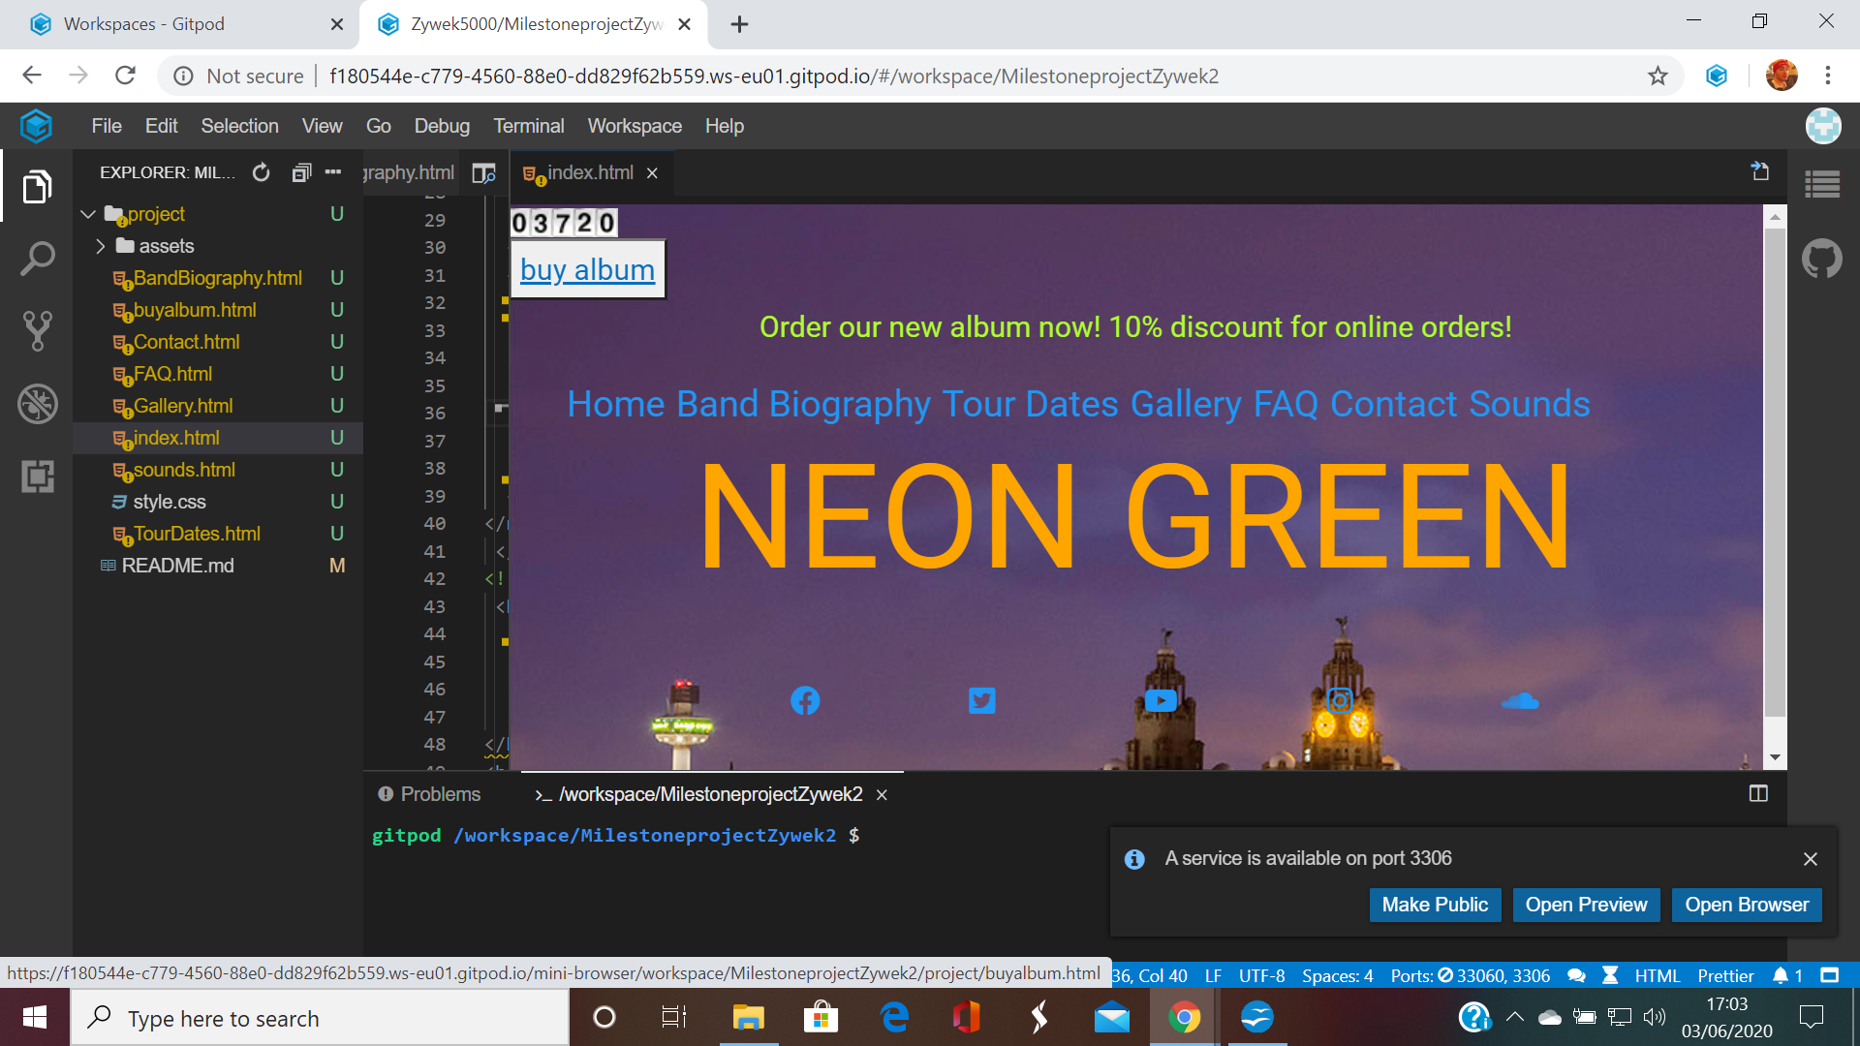

This leads on to the card details page:

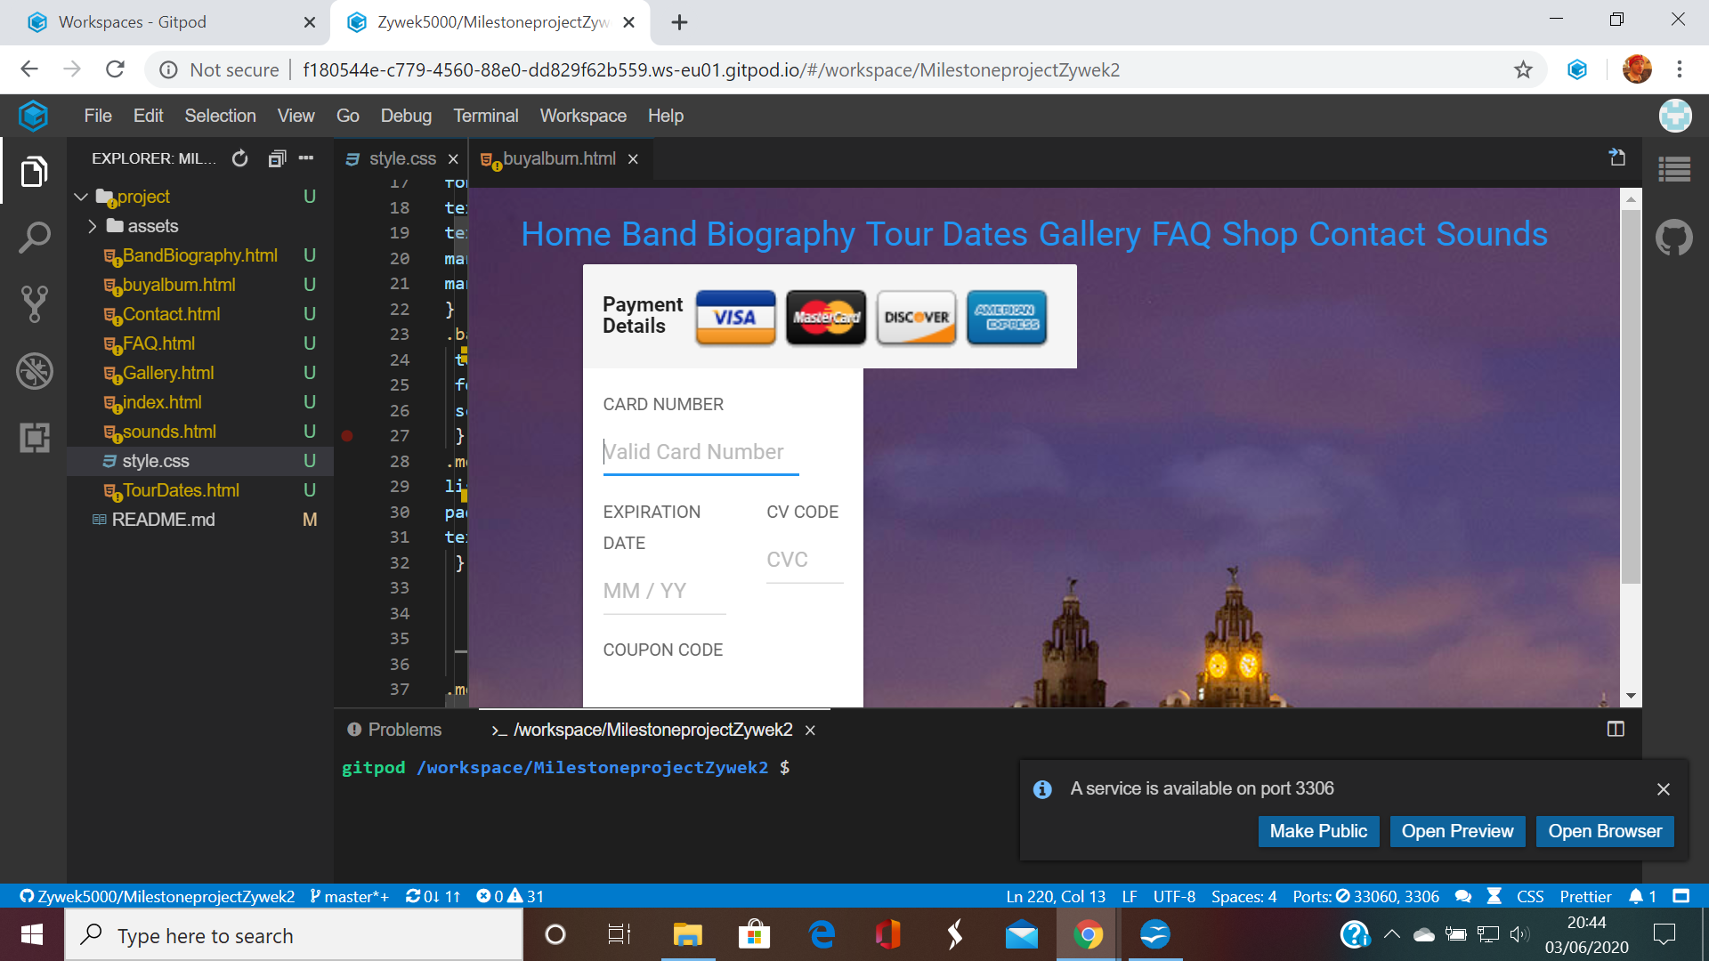
The field for card number is responsive, becoming underlined when the user hovers over it. Likewise, the MM/YY field also responds this way:

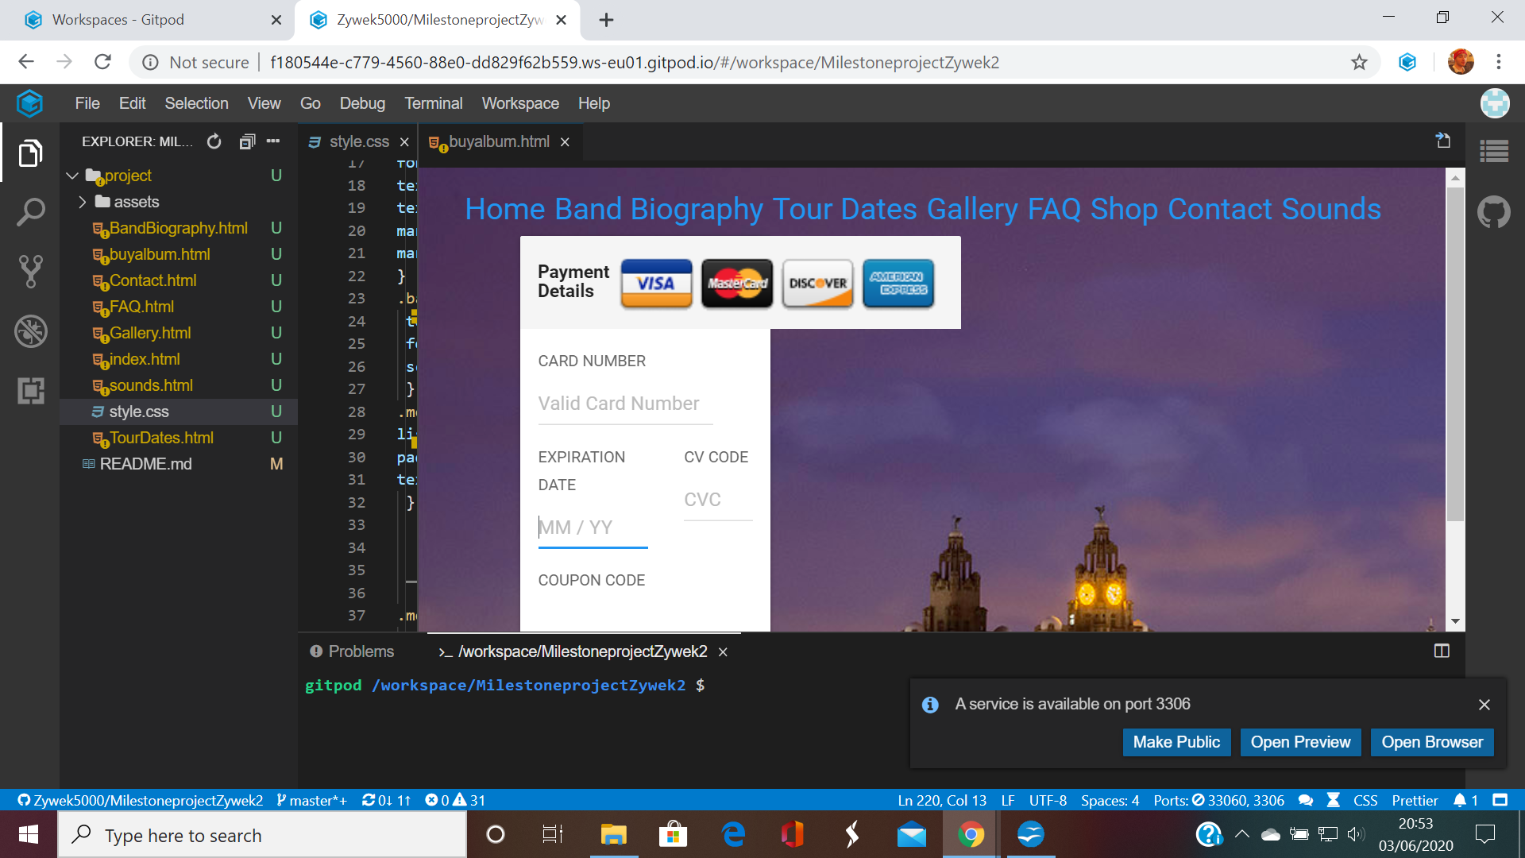
The CVC number is also responsive:
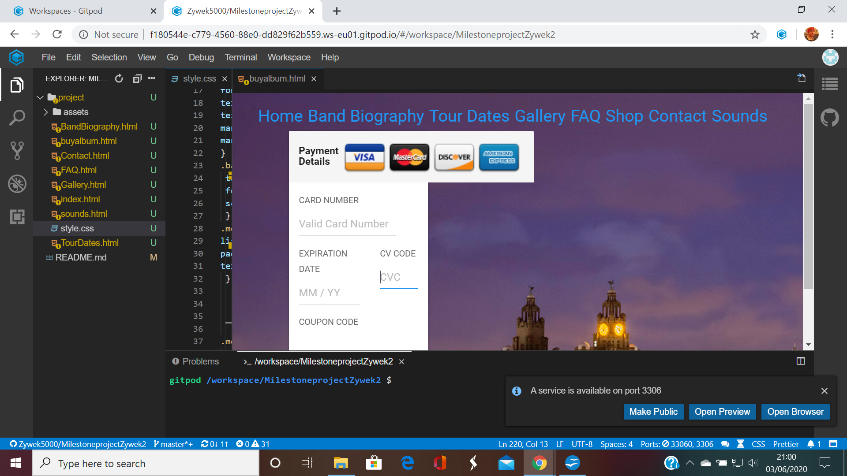

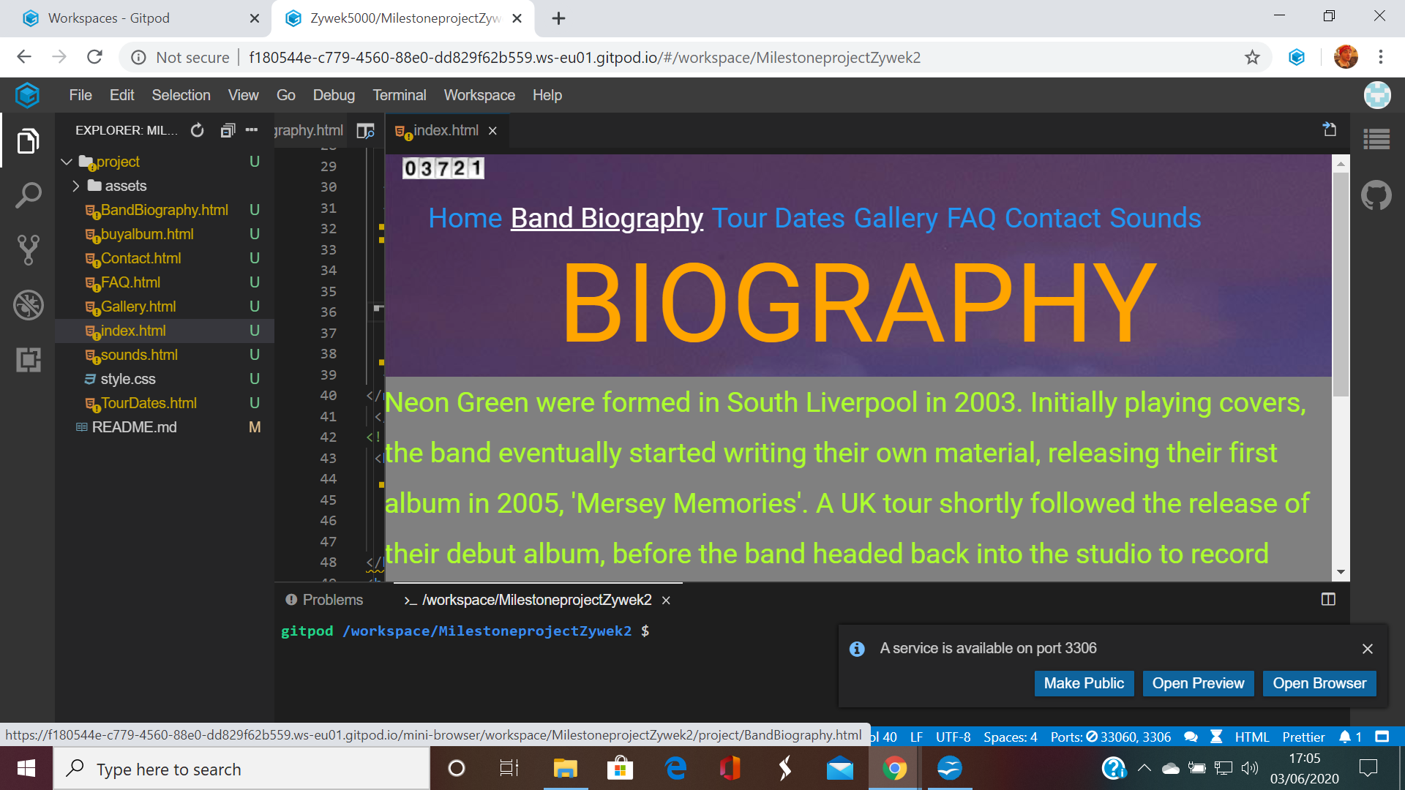
The second page features a short biography of the band, with easy to read, green text, in a grey span, to stop the background picture interfering with the text. Despite this, the background image, or what is still visible, has been kept the same, with respect to a uniform view of the whole site. Again, the link has been highlighted by the cursor.

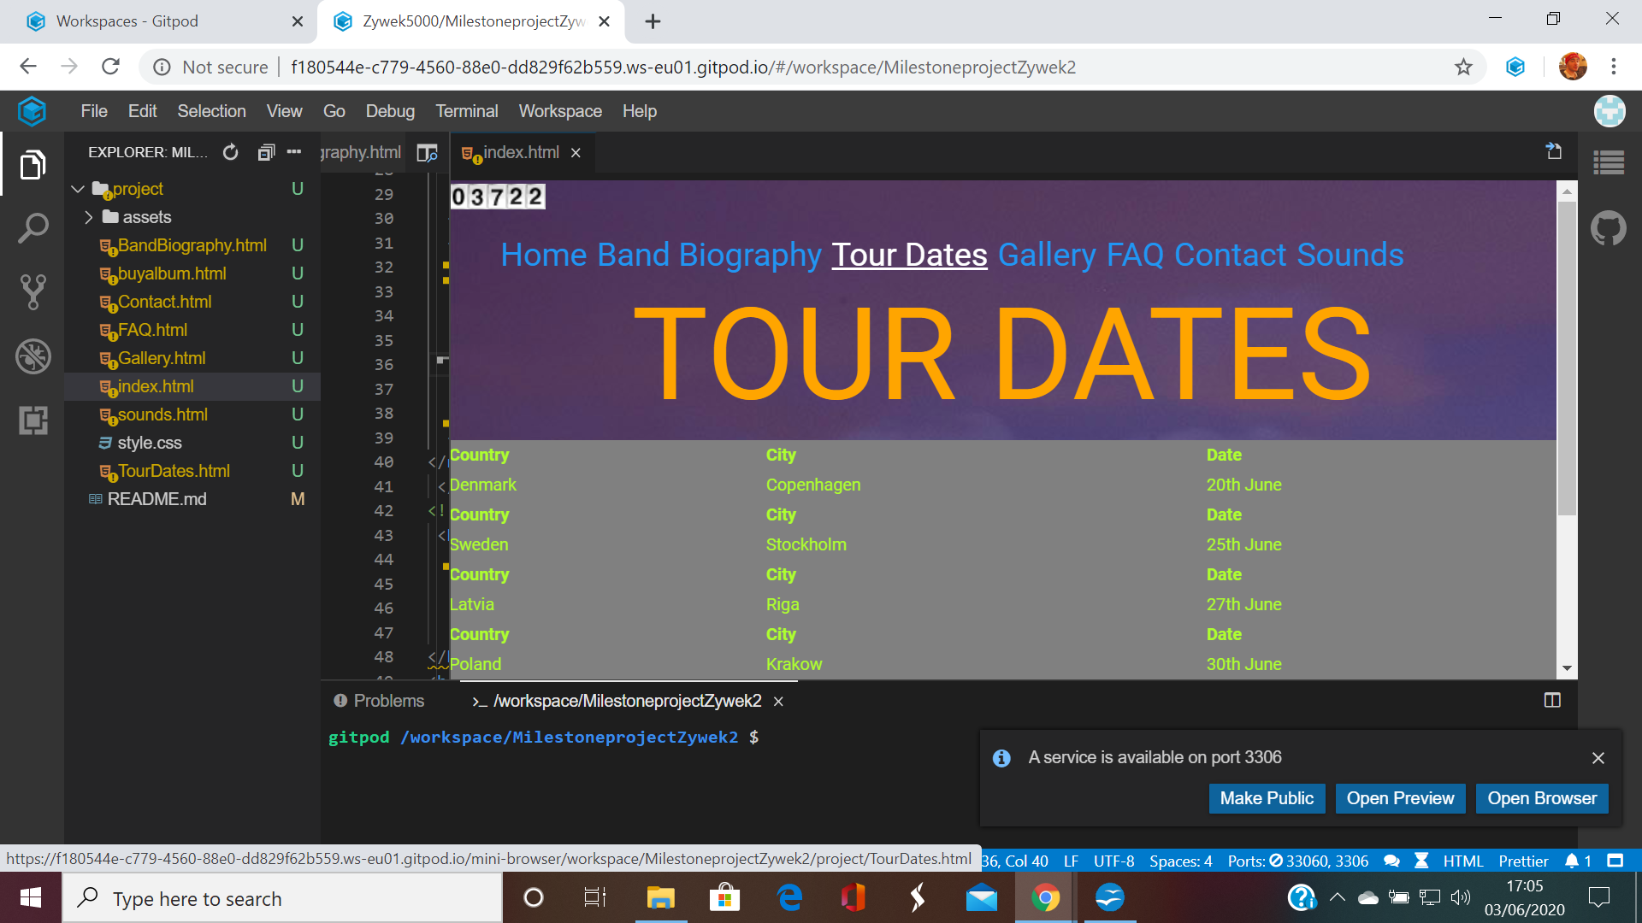
The third page contains information regarding the dates for a European Tour. Once again, a grey span has been used to contain the green text, to stop the background image from getting in the way of the visibility. In line with all the other Nav items, the Tour Dates is highlighted when hovered over, so is responsive.

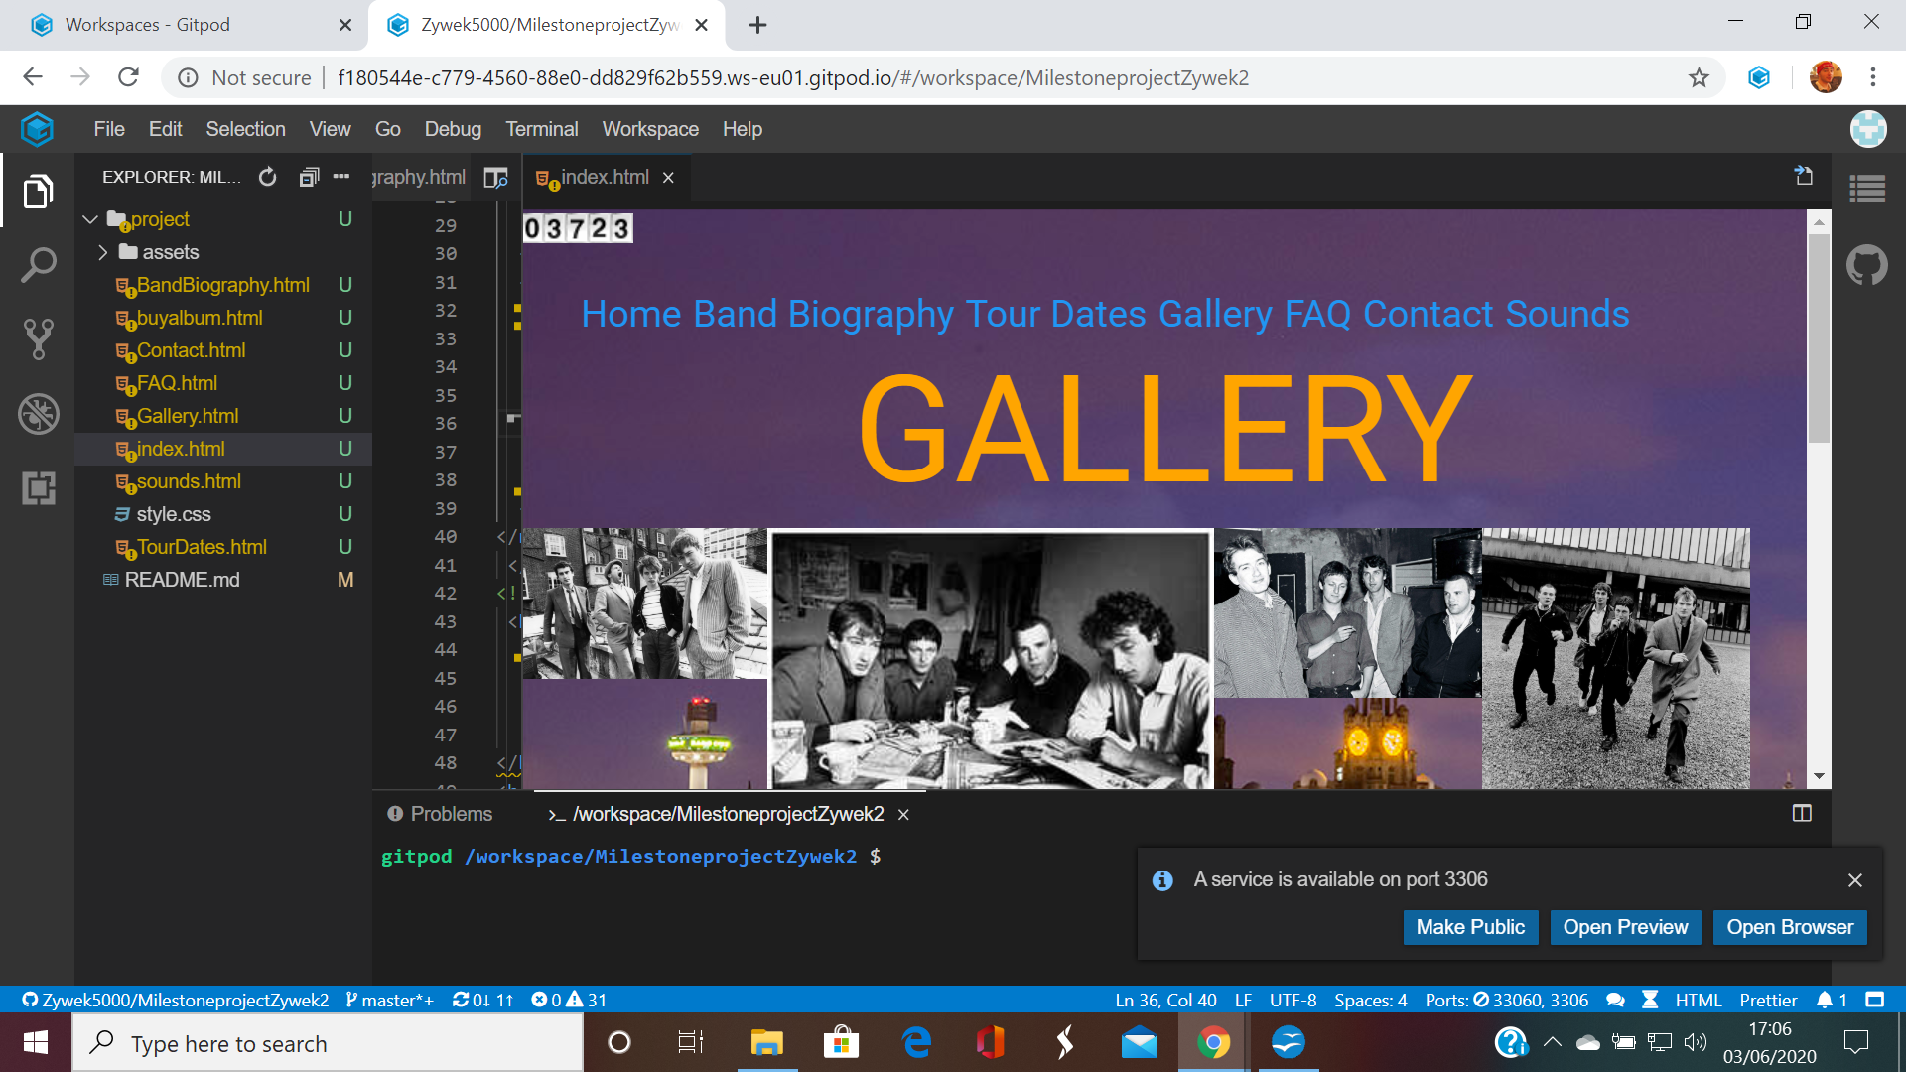

The fourth page features a gallery of the band.

The 'Frequently Asked Questions

The contact page features the same colours as the rest of the site, to give a uniform appearance. Once again, the nav-item is responsive, and becomes highlighted when hovered over:
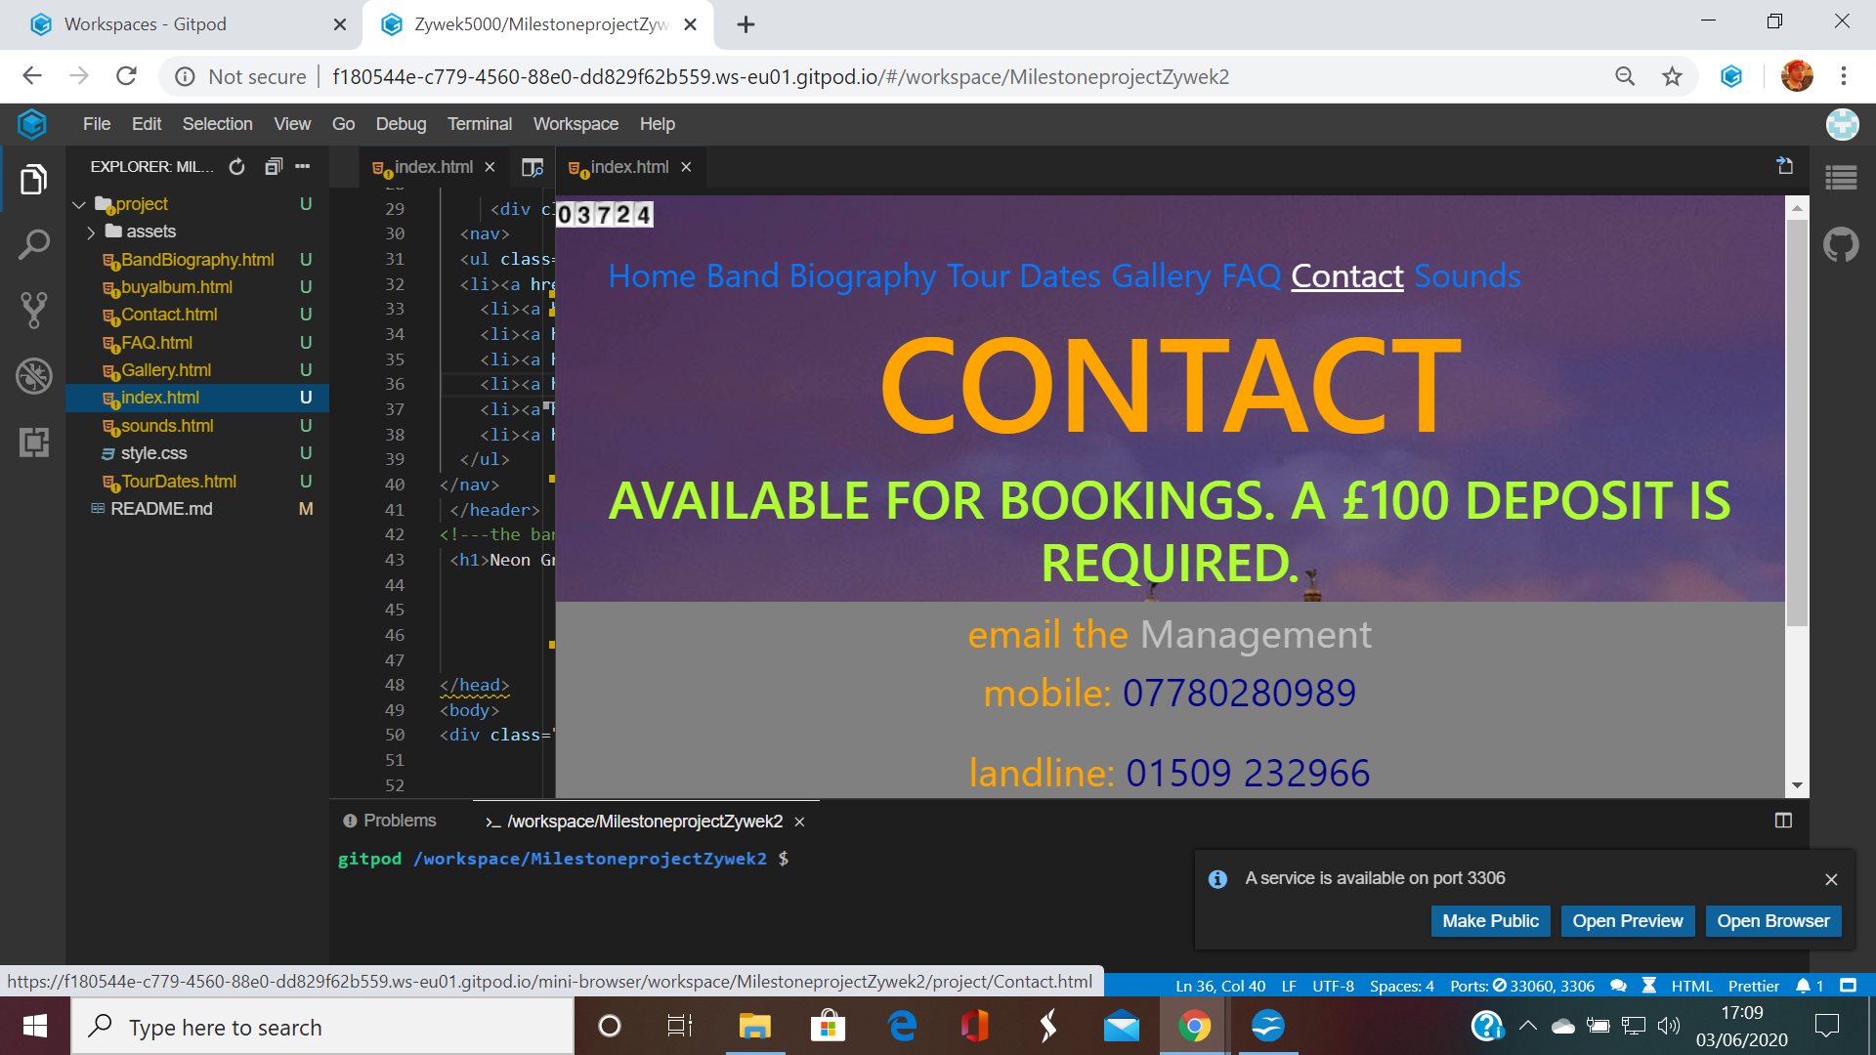
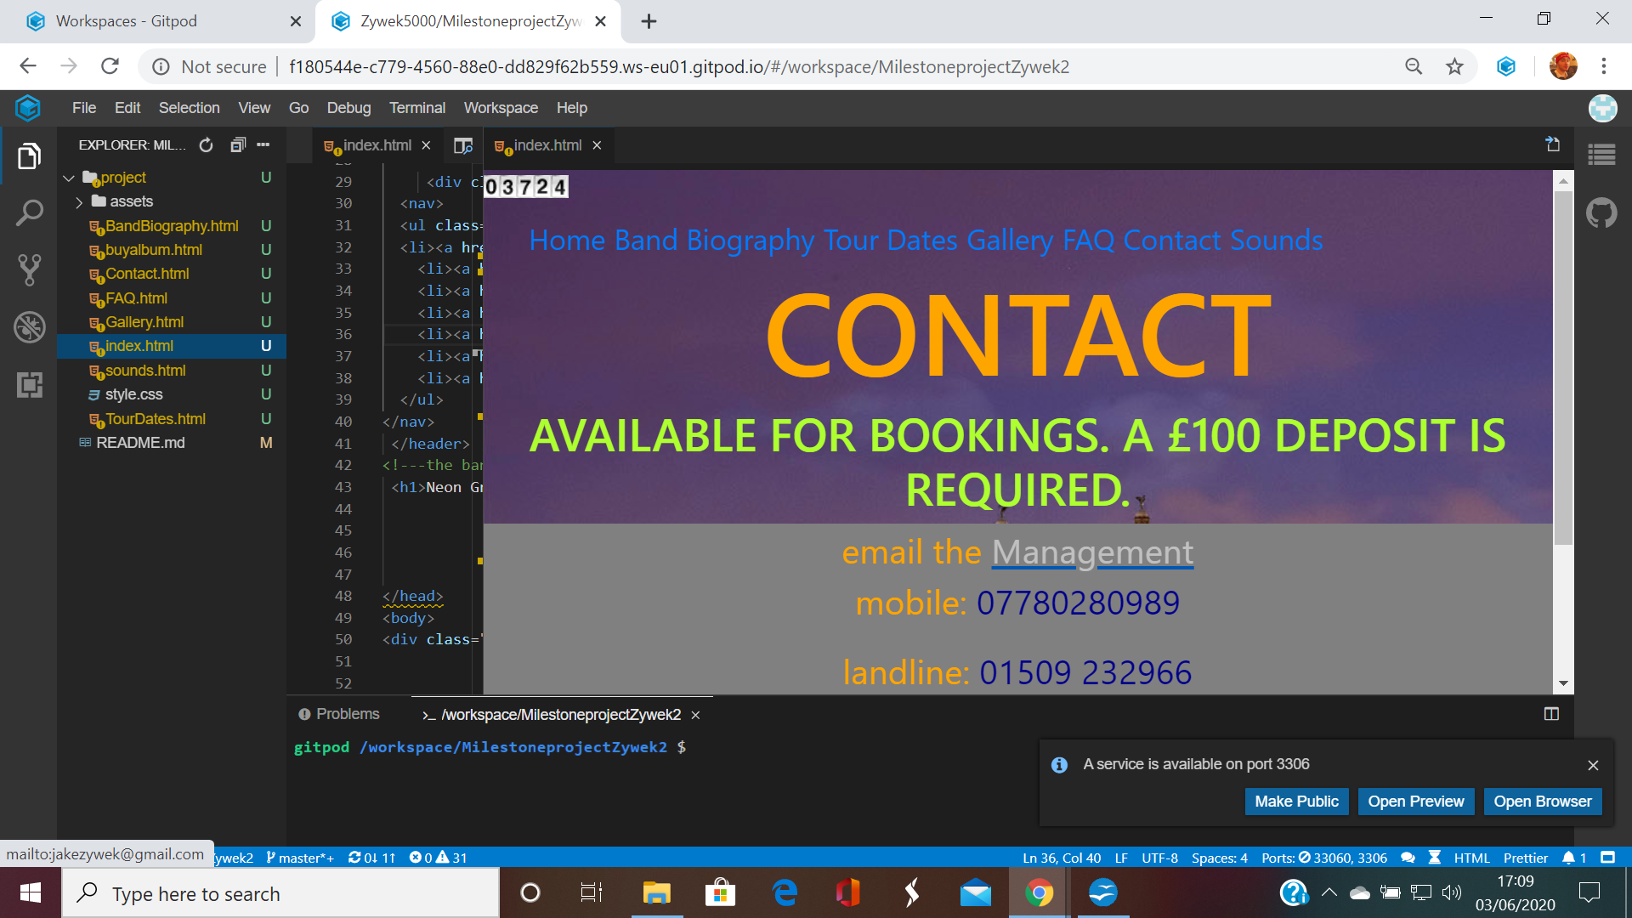
In addition, the email for the management becomes underlined when the user hovers over it:
The H2 text has been kept fairly large and is coloured bright green-informing potential clients a £100 deposit is needed for bookings. Because this is important information, it has been made to stand-out.

In addition, the phone numbers for the management become highlighted when touched with a cursor:
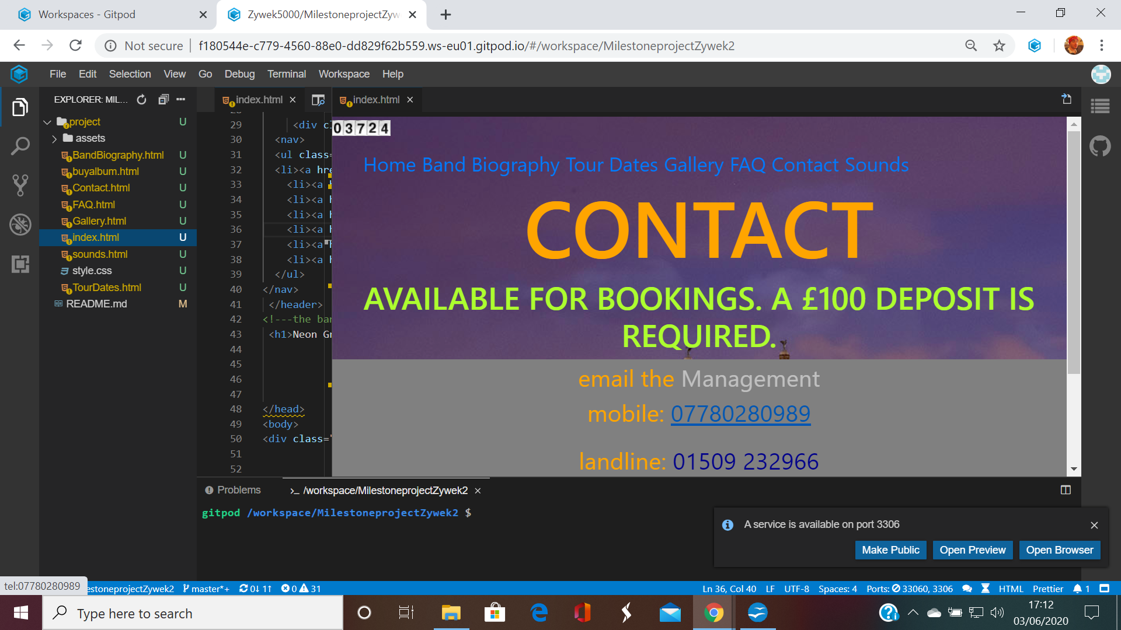
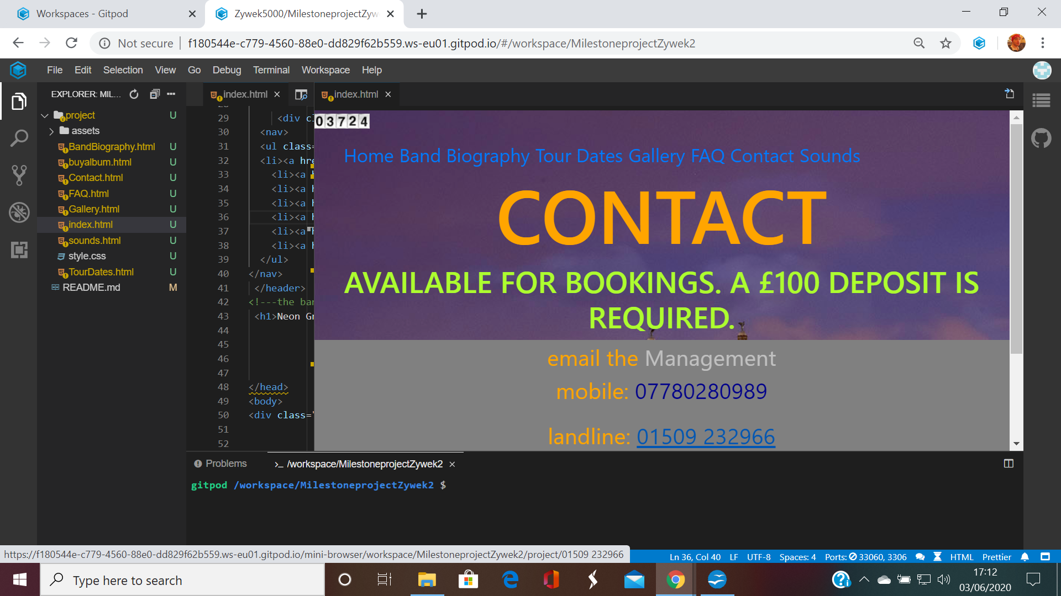

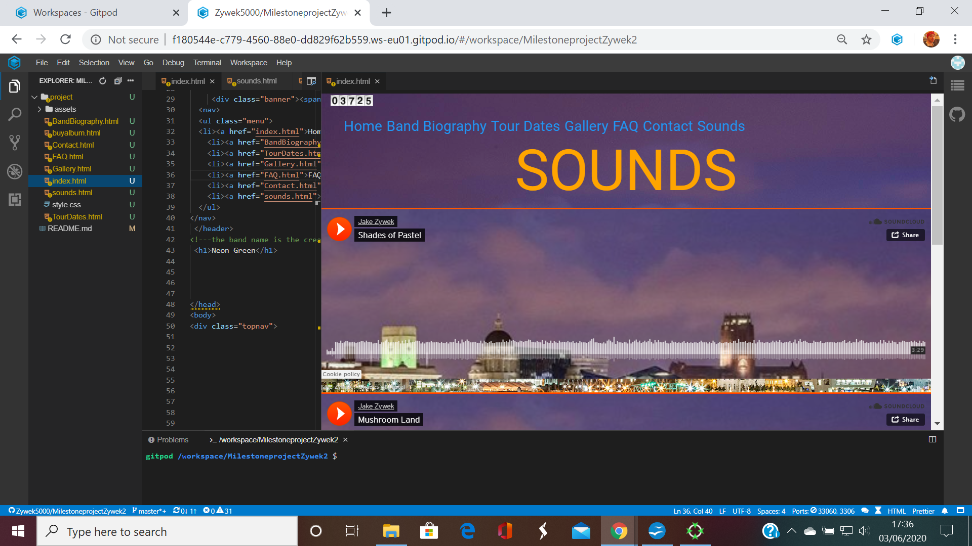
The sounds page gives the user the option to play examples of the band's music. The files are embedded, courtesy of soundcloud. 2 songs are visible above, and the third below:


